A Project Report on

## E-Commerce Website

*Submitted in partial fulfilment for the award of the degree of*

## DIPLOMA

**In**

## Computer Engineering

### By

**G. Praveen Sai Krishna(22243-CM-016)**

**K. Tulasi Satya Ratna Sri(22243-CM-026)**

**K. Yamini (22243-CM-027)**

**R. Sathyanarayana(22243-CM-045)**

**Sk. Siraaj (22243-CM-052)**

**Under the Esteemed Supervision of**

**M Sai Durga Lakshmi ,MCA, Lecture**



**Department of Computer Science and Engineering(Accredited by N.B.A.)**

### SRI VASAVI ENGINEERING COLLEGE (Autonomous)

**(Affiliated to JNTUK, Kakinada)**

**Pedatadepalli,Tadepalligudem-534101,A.P**

**2022-25**

## SRI VASAVI ENGINEERING COLLEGE(Autonomous)

**Diploma**

**in**

**Department of CME**

**Pedatadepalli, Tadepalligudem**



**Certificate**

This is to certify that the Project Report entitled “**E-Commerce Website”** submitted by  **G. Praveen Sai Krishna (22243-CM-016),K. Tulasi Satya Ratna Sri (22243-CM-026),K. Yamini (22243-CM-027), R. Sathyanarayana (22243-CM-045),Sk. Siraaj (22243-CM-052),**in partial fulfillment of the requirements for the award of the degree of Diploma in Computer Engineering from **SRI VASAVI ENGINEERING COLLEGE,** Tadepalligudem, affiliated to the *Jawaharlal Nehru Technological University Kakinada(JNTUK),*is a record of bona fide work carried out by them under my guidance and supervision during the academic year 2024-2025.

| **Project Guide**  **M Sai Durga Lakshmi (MCA)**  Lecturer | **Head of the Department**  Dr. D. Jaya Kumari, M. Tech, Ph.D  Professor & Head |
| --- | --- |
| **Incharge - Polytechnic Courses**  G. Ram Prasad, M. Tech(Ph.D)  Sr. Assistant Professor | **External Examiner** |

**DECLARATION**

We here by declare that the project report entitled” E- Commerce Website” "submitted by us to Sri Vasavi Engineering College (Autonomous), Tadepalligudem, affiliated to JNTUK Kakinada in partial fulfilment of the requirement for the award of the degree of B. Tech in Computer Science and Engineering is a record of Bonafide project work carried out by us under the guidance of **M Sai Durga Lakshmi MCA, Lecturer**. We further declare that the work reported in this project has not been submitted and will not be submitted, either in part or in full, for the award of any other degree in this institute or any other institute or University.

### Project Associates

G. Praveen Sai Krishna(22243-CM-016)

K. Tulasi (22243-CM-026)

K. Yamini(22243-CM-027)

R. Sathyanarayana(22243-CM-045)

Sk. Siraaj(22243-CM-052)

**ACKNOWLEDGEMENT**

First and foremost, we sincerely salute to our esteemed institute **SRI VASAVI ENGINEERING COLLEGE,** for giving us this golden opportunity to fulfill our warm dream to acquire diploma in computer Engineering.

Our sincere gratitude to our project guide **M Sai Durga Lakshmi MCA, Lecturer**  Department of Computer Science and Engineering**,** for his timely cooperation and valuable suggestions while carrying out this project.

We express our sincere thanks and heartful gratitude to **G. Rama Prasad**, Head of the Department, for permitting us to do our project.

We express our sincere thanks and heartful gratitude to **Dr. G.V.N.S.R. Ratnakara Rao**, **Principal**, Sri Vasavi Engineering College for providing a favorable environment and supporting us during the development of this project. Our special thanks to the management and all the teaching and non-teaching staff members, Department of Computer Science and Engineering, for their support and cooperation in various ways during our project work. It is our pleasure to acknowledge the help of all those respected individuals.

We would like to express our gratitude to our parents, friends who helped to complete this project.

### Project Associates

G. Praveen Sai Krishna(22243-CM-016)

K. Tulasi (22243-CM-026)

K. Yamini(22243-CM-027)

R. Sathyanarayana(22243-CM-045)

Sk. Siraaj(22243-CM-052)

**ABSTRACT**

With the advent of technology and with growing occupancy of the people towards it, online shopping has become the need of the hour. With heavy discounts floating over the e-commerce websites, customers find that online shopping allows them to save both time and money. The e-commerce websites on the other hand seek to avail the early advantage of the frequently visited customers through the recommendation engines by using gamification techniques. This tends to make their products highly attractive with the least cost paid by them along with facilities of extra discounts given to debit/credit card holders. This article provides a coherent picture in the research that has taken place in the area of gamification by comprehensively reviewing 1073 research studies extracted from the SCOPUS database and mostly validates the findings on the effectiveness of in the various fields. This article also peer reviews the various motivating factors that makes customers prefer gamified online shopping over market tailers. The review points out the effects of gamification in ecommerce websites in gaining customer retention. The article would also suggest the future of research directions in the field of research and further research that can be explored in the field.

# CHAPTER-1

# INTRODUCTION

##### CHAPTER-1

* 1. **Introduction**

The term Electronic commerce (E-commerce) refers to a [business model](https://www.investopedia.com/terms/b/businessmodel.asp) that allows companies and individuals to buy and sell goods and services over the Internet .Ecommerce operates in four major market segments and can be conducted over computers, tablets, smartphones, and other smart devices. Nearly every imaginable product and service is available through ecommerce transactions, including books, music, plane tickets, and [financial](https://www.investopedia.com/ask/answers/030315/what-financial-services-sector.asp) [services](https://www.investopedia.com/ask/answers/030315/what-financial-services-sector.asp) such as stock investing and online banking. As such, it Is considered a very [disruptive technology](https://www.investopedia.com/terms/d/disruptive-technology.asp).

E-commerce originated in a standard for the exchange of business documents, such as orders or invoices, between suppliers and their business customers. Those origins date to the 1948–49 Berlin blockade and airlift with a system of ordering goods primarily via telex.

WE are living in E-century. The Internet and information and communications Technologies (ICT) are central to economic growth and productivity. Internet-based technologies and networks can increase productivity, decrease costs and open new market opportunities. Now-a-days, using the Internet and email to conduct business is not uncommon. However, lack of technical and management skills in Information and Communications Technology is a barrier. There are a wide variety of resources available to help you to improve your e-commerce skills. Simply, decide what skills you need and identify the appropriate Resources to help you to build those skills. The skills that may be required range from basic abilities, like word processing and Internet navigation, to more complex capabilities such as designing and building websites and database management. There are a range of resources to help you broaden your understanding of the E-commerce environment and develop our technical skills. These include online resources, books and magazines, seminars and training courses. Keeping this in mind, a summary on the background of Electronic Commerce is being provided.

##### Definition

The definition of e-commerce includes business activities that are business-to-business (B2B), business-to-consumer (B2C), extended enterprise computing (also known as "newly emerging value chains"), d-commerce, and m-commerce.

E-commerce is simply a part E-business, more specifically, the trading aspect of E-business. Although there are many definitions and explanations of E-commerce, the following definition provides a clear distinction.

There are many definitions and understanding about E-Commerce. They are as follows:

1. According to the editor -in-chief of International Journal of Electronic Commerce, Vladimir Zwass, ‘Electronic commerce is sharing business information, maintaining business relationships and conducting business transactions by means of telecommunications networks’.
2. Electronic Commerce is where business transactions take place viatele communications networks, especially the Internet – E. Turban, J. Lee, D.King and H.M. Chung,
3. Electronic commerce is about doing business selectronically –P.Timmers
4. Electronic commerce ore-commerce refers to a wide range of online business activities for products and services – Anita Rosen.

##### Problem Identification

The tragedy of e-commerce can be measured in percentage: 75.8% (almost 8out of 10) of online shopping carts are abandoned without the purchase being completed. Deficient checkout processes are often singled out as the main cause, but many other problems faced by e-commerce consumers could be behind it. Slow load times, poor return policies, lack of customer warranties or absurd requirements are among the problems that make online shopping difficult. In the following lines, you will discover these and other bad practices that reduce the commercial performance of online stores, knowing them is the best way to avoid them!

E-commerce provides an easy way to sell products to a large customer base. However, there is a lot of competition among multiple e-commerce sites. When uses e-commerce site, they expect to find what they are looking for quickly and easily. Also, users are not sure about the brands or the actual products they want to purchase. They have a very broad idea about what they want to buy. Many customers nowadays search for their products on Google rather than visiting specific e-commerce sites. They believe that Google will take them to the e-commerce sites that have their product.

The purpose of any e-commerce website is to help customers narrow down their broad ideas and enable them to finalize the products they want to purchase. For example, suppose a customer is interested in purchasing a mobile. His or her search for a mobile should list mobile brands, operating systems on mobiles, screen size of mobiles, and all other features as facets As the customer selects more and more features inherits from the facets.

##### Objectives of the Study

* Primary Objective.
  + - A Study on Emerging of E-commerce.

##### Secondary Objective.

* Reduce management costs.
* Developing business relations.
* Providing a unique customer experience.
* Increasing the number of loyal customer.
* Making responsive e-commerce website.
* Increasing sales.
* Development of Business-Relationship.
* Better-Customer Service
* Getting more Customers.

##### Limitations of the Study

* Return-on-investment is difficult to calculate.
* Many firms have had trouble recruiting and retaining employees with the technological, design, and business process skills needed to create an effective electronic commerce presence.
* Difficulty of integrating existing databases and transaction-processing software designed for traditional commerce into the software that enables electronic commerce
* Many businesses face cultural and legal obstacles to conducting electronic commerce.
* Facing increased competition from both national and international competitors often leads to price wars and subsequent unsustainable losses for the organization.
* Computing equipment is needed for individuals to participate in the new ‘digital’ economy, which means an initial capital cost to customers.
* A basic technical knowledge is required of both computing equipment and navigation of the Internet and the World Wide Web.

**CHAPTER-2**

**LITERATURE SURVEY**

##### CHAPTER-2

* **2.1 Review of Literature**
* Gupta (2014) in her paper “E-Commerce: Role of e-commerce in today’s business”, presents a comprehensive definition of e-commerce while isolating it from e-business. The paper enlists the different ecommerce models i.e. B2B,B2C, B2G and narratively analyzing the every aspect of it.
* Gunasekaran, Marri, Mc Gauhey & Nehwani (2002) give a broad outlook of electronic commerce within organizational system in “E-commerce and its impact on operations managements” defining it with reference to e-trading and elaborating- how it has permeated every field of business. The paper identifies the revolutionary changes brought by the internet applications like e-mail and electronic data interchange and details the revolutionary changes brought by the internet technologies in manufacturing, marketing, purchasing, design, productions, selling and distributions, warehousing and human resources management. Internet based technologies have enable businesses to shorten development purchase and procurement cycles, maintain up to date product and market information, significantly increase the speed of communications and increase the quality of customer relationships by facilitating close contact and constant communication. The paper studies in depth, the significance of web based technologies in different business operations, thus improving their efficiency through effective B2B E-commerce.
* Mishra & Kotkar (2015) trace the timeline and development of B2C e-commerce “A study on current status of e-commerce in India: A Comparative analysis of flip kart and Amazon” with its inception in the mid 1990’s through the land job portals. However, due to limited internet accessibility, weak online payment systems and lack of awareness, the progress was very slow. The Indian B2C E-commerce industry got a major boost in mid-2000 with the expansions of online services to travel and hotel bookings which continue to be major contributor.
* With the E-commerce markets in the west reaching their saturations, investors see tremendous potentials in the Indian markets, in the light of which, many startups have received funding from venture capita lists and private equity.

1)New York from Tiger Global Management has funded companied Make My Trip, Flip kart, Myntra and Quickr. The availability of funds has presented a favorable ecosystem and growth opportunities for is as well as small companies. It has enabled local startups to survive in cut throat competition against foreign giants and has facilitated the penetration of e-commerce to every facet of human life such that the differentiation between e-commerce and traditional business is getting burred (Agarwal, 2014).

2)Through “ Problems and Prospects of E-Commerce”, Raghunath & Pauga(2013) present a comprehensive analysis of various menaces of e-commerce while accentuating that, in present time every business activity , be it advertising , ordering , payment etc., can be performed in the digital ecosystem . The paper also enlists numerous points that has the importance of e-commerce which is responsible for its development as the new convention. It has enabled the creation and exploitation of new business opportunities, at the same time increasing the way of customers in the development of new products and services. E-commerce has not only augmented the performance of internal business management, but has also enabled better customer relationships by promoting a business model that is essentially based on information sharing. SWOT analysis of e-commerce conducted by Awais & Samin (2012) highlights low operating cost, improved customer interaction and time saving as the unique strengths of e-commerce, but at the same time it is noticeable on the necessity for the firms to adapt themselves to the changing environment and innovate constantly to come up with better offerings for customers.

* (Das & Ara, 2015). In the face of rising competition, the survival of the firms will depend upon how efficiently they are able to bridge the existing gaps in e-commerce transactions. The ubiquitous nature of internet has enabled e-commerce to defy geographical boundaries In the light of growing number of website, offering similar goods and services, greater significance is being attributed to Internet. Marketing, which shall play and unparalleled role in audience acquisition for E-commerce websites, by displaying the advertisement on search engine result pages and other portals.

##### Scope Of The Study

Today, online shopping is a reality in India. The market place is flooded with several ecommerce options for shoppers to choose from. In the recent past, the growth of e-commerce industry in India has been phenomenal as more shoppers have started discovering the benefits of using this platform. There is enough scope for online businesses in the future if they understand the Indian shopper’s psyche and cater to their needs. Listed below are the reasons that guarantee the future prospect of E-commerce in India.

* + - Enhancing domain registrations,
    - Rising internet users,
    - Easy access to internet,
    - Awareness about internet even in rural areas,
    - Rising number of cyber cafes,
    - Growing need for E-commerce.

**CHAPTER-3**

**SYSTEM STUDY AND ANALYSIS**

### CHAPTER-3

**3.1 Problem Statement:** This could include challenges such as poor user experience, security vulnerabilities, slow loading times, and limited payment options. Emphasize how these issues impact customer satisfaction and sales.

* 1. **Existing System:** These are some existing systems
* Custom-Built Systems
* Open-Source Platforms
* Hosted E-commerce Solutions
* Headless Commerce:
* Enterprise E-commerce Platforms
  1. **Limitations Of Existing System:**

**Factors to Consider When Choosing a System:**

* **Scalability:** Can the system handle future growth
* **Customization:** How flexible is the system for tailoring to specific needs
* **Cost:** What are the initial and ongoing costs associated with the system
* **Security:** How secure is the system against data breaches and cyber threats
* **Integration:** Can the system integrate with other business systems

**3.4 Proposed System:**

Outline your proposed e-commerce solution. Describe the architecture, technologies to be used, and how it addresses the limitations of existing systems. Emphasize features such as:

* Enhanced user interface and experience
* Robust security measures
* Scalable infrastructure
* Integration capabilities with third-party services

**3.5 Advantages Of Proposed System:**

* Improved User Experience: Intuitive design and faster loading times.
* Increased Security: Enhanced protocols for data protection
* Flexibility: Ability to tailor functionalities based on business needs.
* Scalability: Seamless handling of growing traffic and product listings.
* Better Analytics: Advanced tools for tracking user behaviour and sales performance.

**3.6 Functional Requirements:**

* Product details
* Discounts
* Promotions & Social Media Integration
* Customer care and Support

**3.7 Non-Functional Requirements:**

* Performance: Fast loading times, capable of handling multiple users.
* Reliability: High availability and minimal downtime.
* Scalability: Ability to grow with increasing user demand.
* Usability: Easy to navigate for all user demographics.

**3.8 User Interface Requirements:**

* Responsiveness: Ensure compatibility across devices (desktop, tablet, mobile).
* Intuitive Navigation: Clear menus and product categories.
* Visual Appeal: Aesthetically pleasing layout with consistent branding.
* Accessibility: Compliance with accessibility standards for users with disabilities.

**3.8.1 Software Requirements:**

* Web Server: Apache, Nginx, etc.
* Database Management System: MySQL, PostgreSQL, etc.
* Programming Languages: PHP, Python, JavaScript, HTML, CSS, etc.
* Frameworks: Laravel, Django, React, etc.
* Content Management System: WordPress or custom-built

**3.8.2 Hardware Requirements:**

* Server Specifications: CPU, RAM, and storage needs based on expected traffic.
* Network Infrastructure: Reliable internet connection and bandwidth.
* Backup Solutions: Hardware or cloud solutions for data backup.

**CHAPTER-4**

**Architecture Pattern**

### CHAPTER-4

##### 4.1Architecture Pattern:

Several architectural patterns can be used for e-commerce websites:

**Monolithic Architecture:** All components are bundled into a single one application. Simple to develop and deploy but can become difficult to maintain and scale as the website grows.

**Microservices Architecture:** The application is broken down into smaller independent services that communicate via APIs. Offers better scalability, flexibility

and fault tolerance but can be complex to manage.

**Headless Commerce:** The frontend and backend are decoupled, allowing for greater flexibility in choosing technology stacks and customizing the user experience.

##### 4.1.1: Technology Stack:

A typical technology stack include:

* Frontend: HTML, CSS, JavaScript, React, Angular, or Vue.js
* Backend: Node.js, Python (Django or Flask), Ruby on Rails, or Java
* Database: MySQL, PostgreSQL, MongoDB, or Amazon DynamoDB
* Cloud Platform: AWS, Google Cloud Platform, or Azure
* Payment Gateway: Stripe, PayPal, or Braintree
* Content Delivery Network: Cloudflare, Akamai, or Fastly

##### 4.1.2 Image Management:

Storage: Store images in a cloud storage service like Amazon S3 or Google Cloud Storage.

Optimization: Use tools to compress images without sacrificing quality, reducing load times.

CDN: Distribute images across multiple servers using a CDN for faster delivery.

Lazy Loading: Load images only when they are visible in the viewport to improve initial page load speed.

##### 4.1.3 Security Considerations:

* Data Encryption:Protect sensitive data like customer information and payment details using encryption.
* Regular Updates: Keep software and libraries up-to-date to address security.
* Web Application Firewall (WAF): Use a WAF to protect against common web attacks like SQL injection and cross-site scripting.
* Secure Coding Practices: Follow secure coding guidelines to prevent common security pitfalls.

##### 4.1.4 Scalability:

* Horizontal Scaling: Add more servers to handle increased traffic.
* Vertical Scaling: Upgrade existing servers with more powerful hardware.
* Caching: Store frequently accessed data in memory to reduce database load.
* Content Delivery Network: Distribute content across multiple locations for faster deliver

##### 4.2 Design:

A server-client architecture is a distributed computing model where a central server provides services to multiple clients. This model is widely used in

various applications, including web servers, database servers, and file servers.

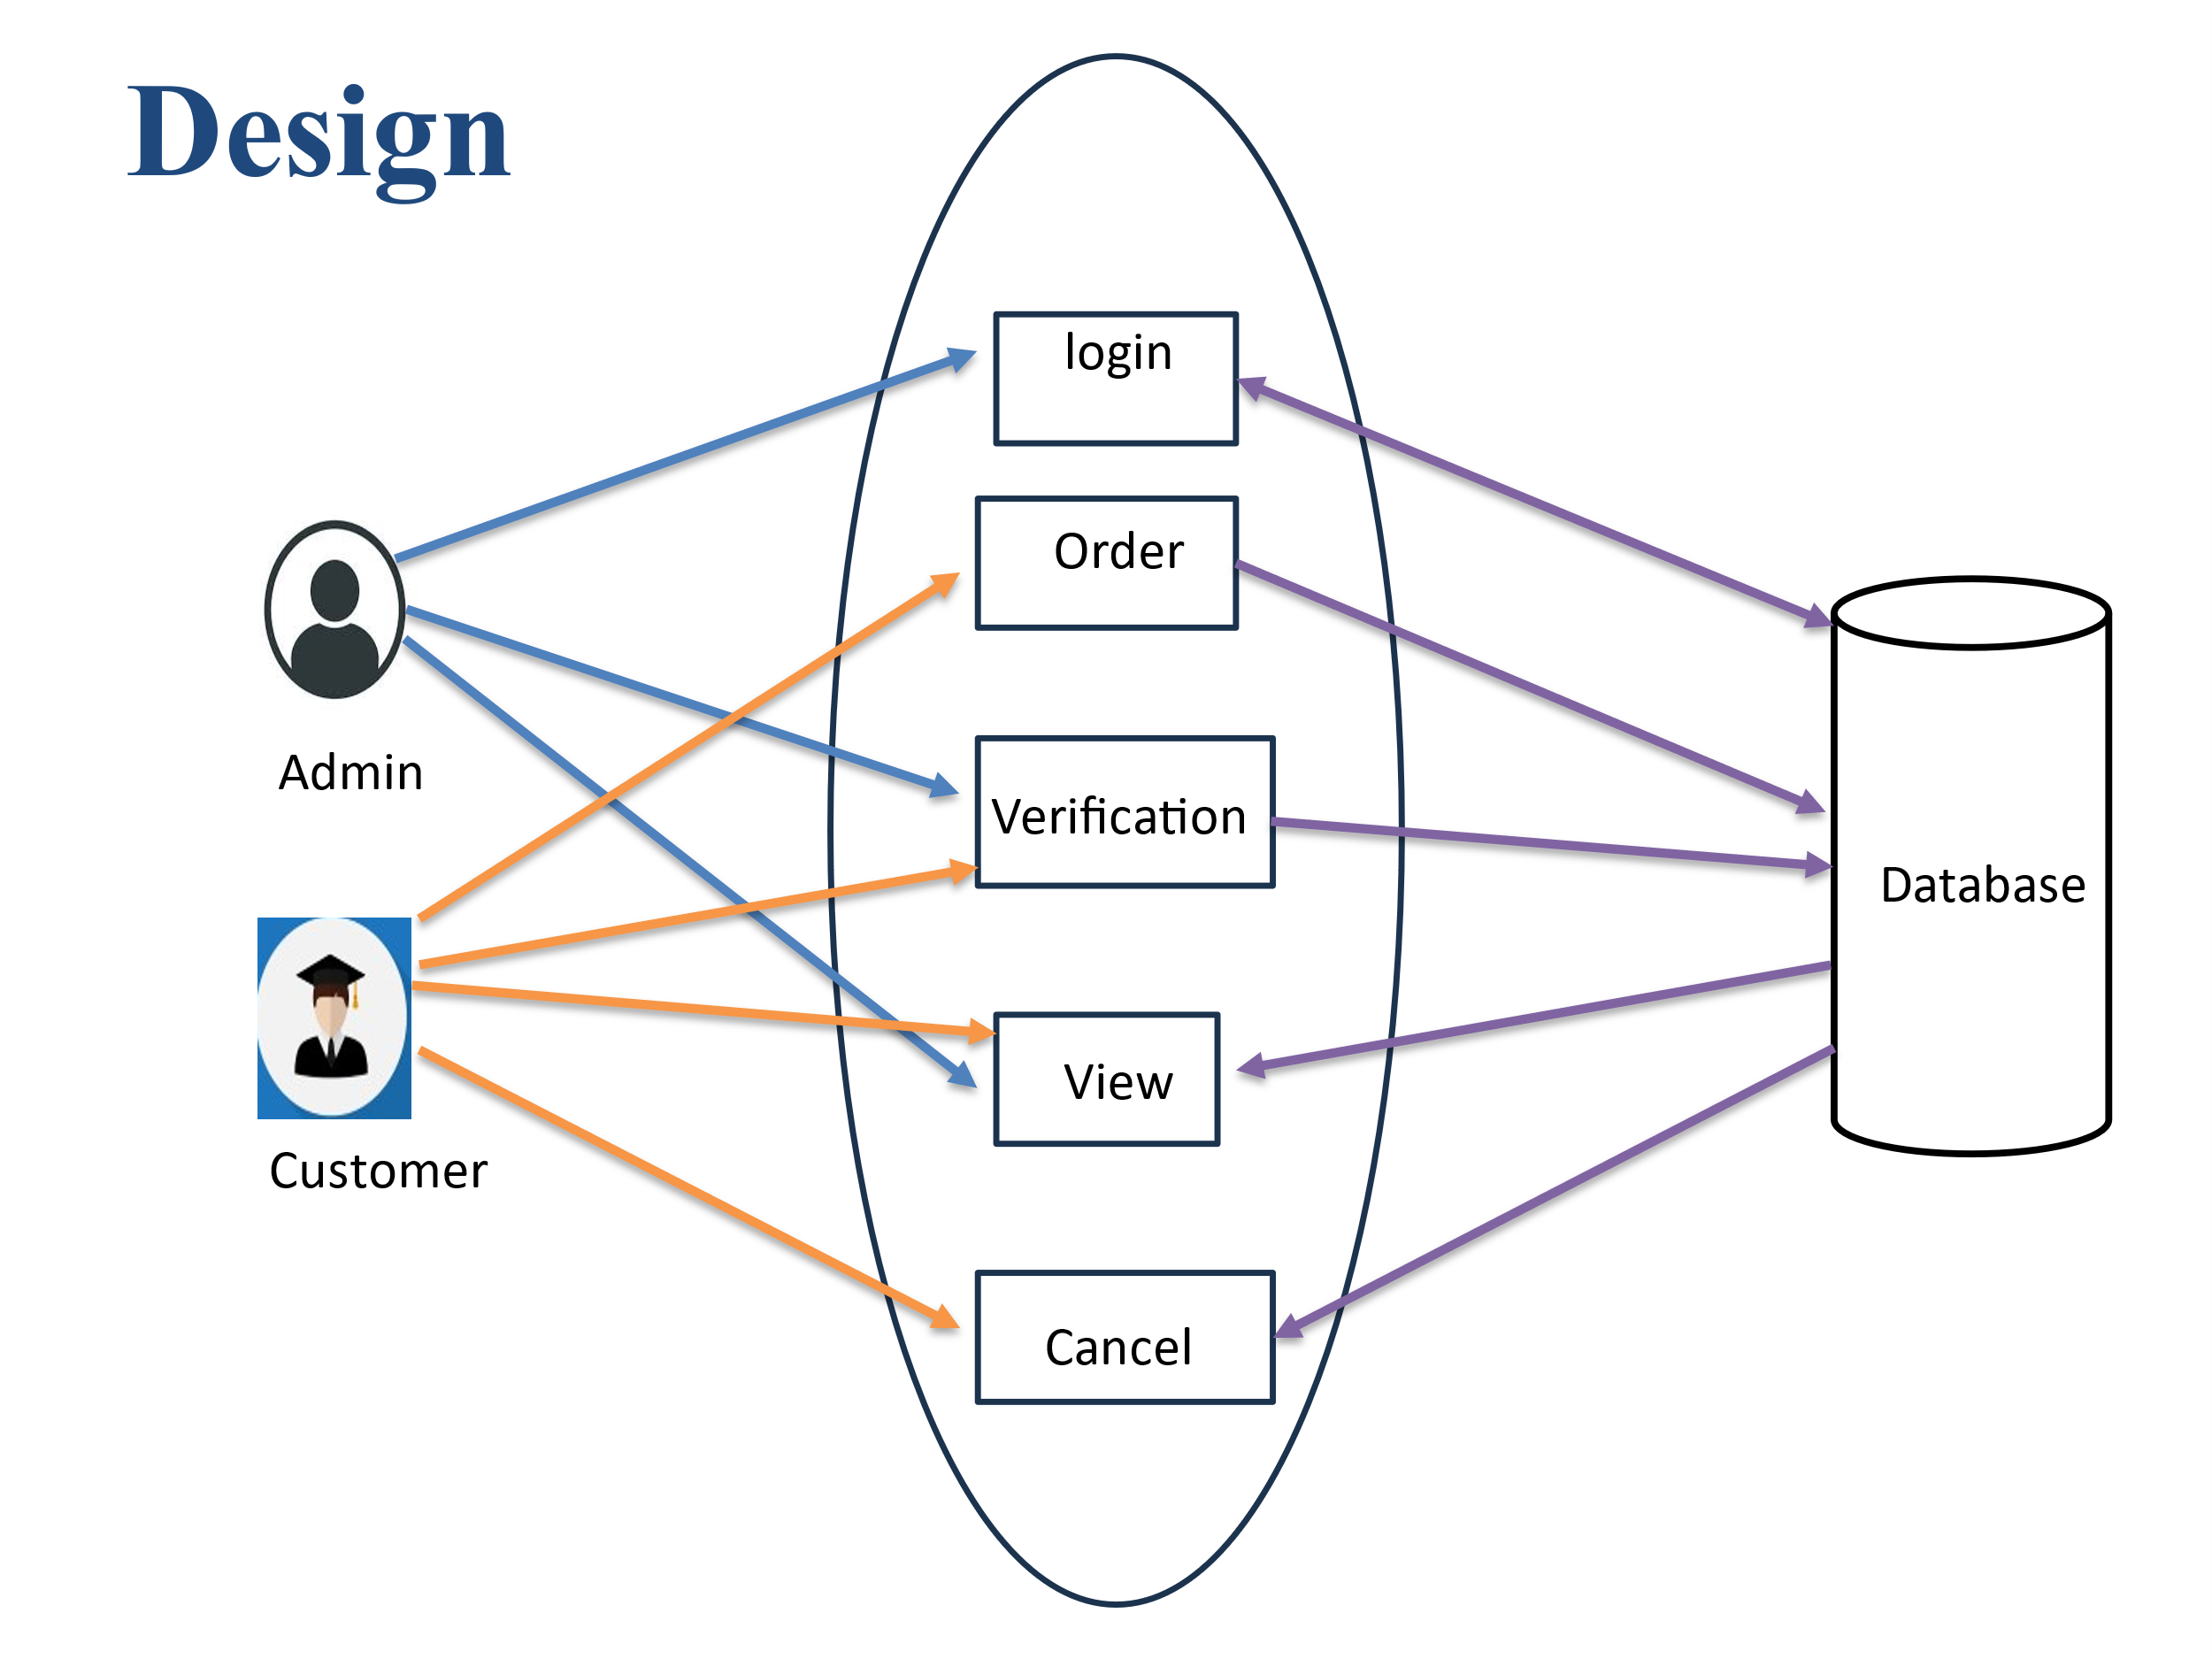

Class diagram are the blueprints of your system or subsystem. You can use class diagrams to model the objects that make up the system, to display the relationships between the objects, and to describe what those objects do and the services that they provide. Class diagrams are useful in many stages of system design.

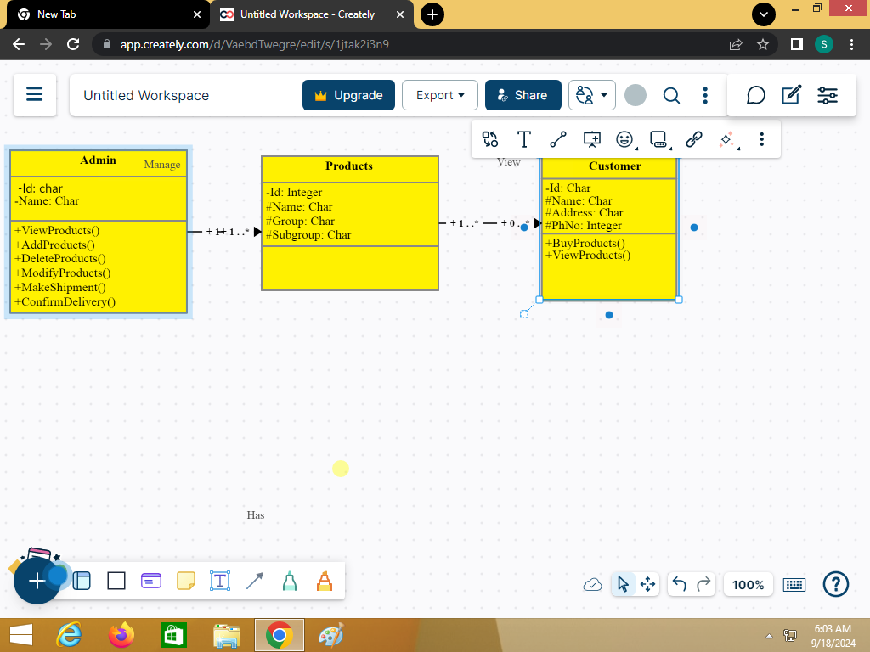

Class Diagram

### CHAPTER-5

### TECHNOLOGIES

### CHAPTER-5

##### 5.1 Front-End Technologies:

* **HTML (Hypertext Markup Language):** The foundation of web pages, defining the structure and content.
* **CSS (Cascading Style Sheets):** Used to style the appearance of web pages, including layout, colours, fonts, and more.
* **JavaScript:** A programming language that adds interactivity and dynamic elements to web pages, such as animations, form validation.

**5.2 Back-End Technologies:**

* **Server-Side Programming Language:** Options include PHP, Python, Ruby, Node.js, or Java. We have Used PHP.
* **Database Management System:** MySQL, PostgreSQL, MongoDB, or Oracle are common choices for storing product data, customer information, and orders.
* **E-commerce Platform:** Consider using a pre-built platform like WooCommerce, Magento, or Shopify to streamline development and provide essential features.

**5.3 Apps Used:**

* Canava for Editing
* VS Code & Notepad++ For Coding
* Pinterest for Information gathering
* Xmapp for Data-base Operations

### CHAPTER-6

### IMPLEMENTATION

### CHAPTER-6

##### 6.1 Implementation

##### After Navigation to the main page we to select the products according to the your need

##### After Choosing the Product you need to Order the product.

* After Pressing on the Buy now you need to enter your details.
* And Submit the details for the Admin
* The User can Check the order was placed or not.
* By Entering the mobile number then the Details of the order will be displayed if there is no data on number it will show as the data not found.

### CHAPTER-7

### TESTING

### CHAPTER-7

**7.1 Introduction to Testing:**

Testing is a critical phase in the development of an e-commerce website. It ensures that the platform functions as intended, providing a seamless user experience while maintaining security and performance. Given the competitive nature of online retail, effective testing can significantly impact customer satisfaction and retention.

**7.2 Testing:**

* Functional Testing: Verifies that all functionalities work as intended. This includes testing user registration, login, product search, checkout process, and payment processing.
* Usability Testing: Focuses on the user interface and overall experience. It involves observing real users as they interact with the site to identify areas for improvement.
* Performance Testing: Assesses how the website performs under different load conditions. Tools like JMeter or LoadRunner can simulate high traffic and measure response times.
* Security Testing: Identifies vulnerabilities in the system. This includes penetration testing, checking for SQL injection risks, and ensuring data encryption.
* Compatibility Testing: Ensures that the website functions correctly across various browsers (Chrome, Firefox, Safari) and devices (mobile, tablet, desktop).
* Regression Testing: Conducted after updates or changes to ensure that new code has not introduced any issues in existing functionalities.

### CHAPTER-8

### SCREENSHOTS

### CHAPTER-8

Figure1: Main Page

Figure 2: Shoe Store 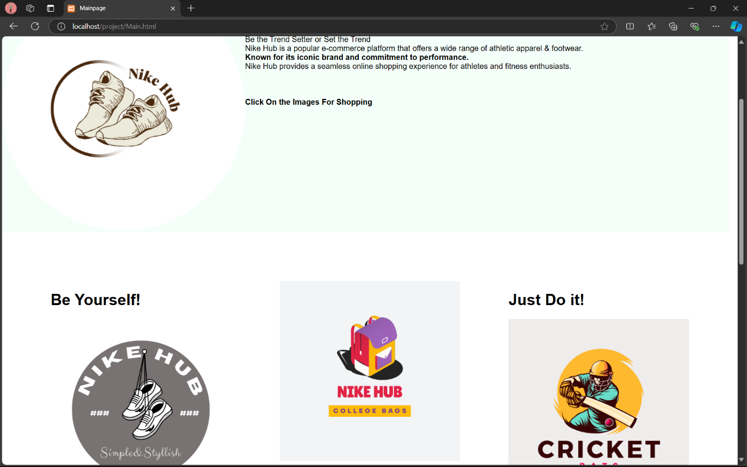

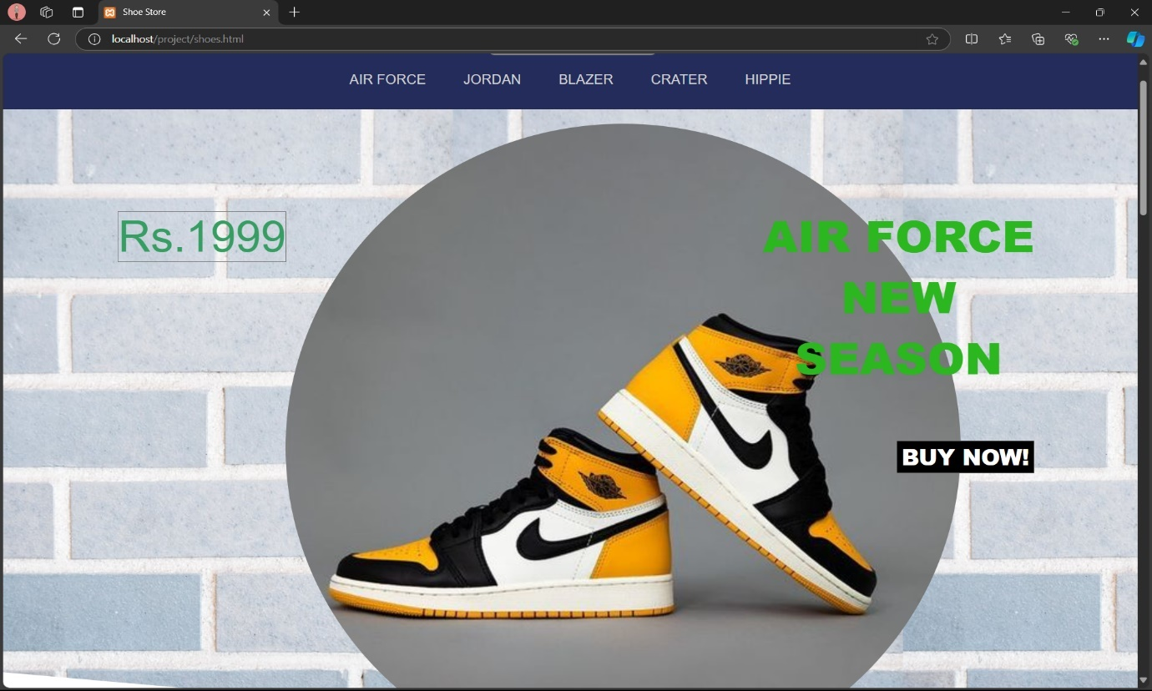

Figure 3: Bag Store

Figure 4: Bat Store

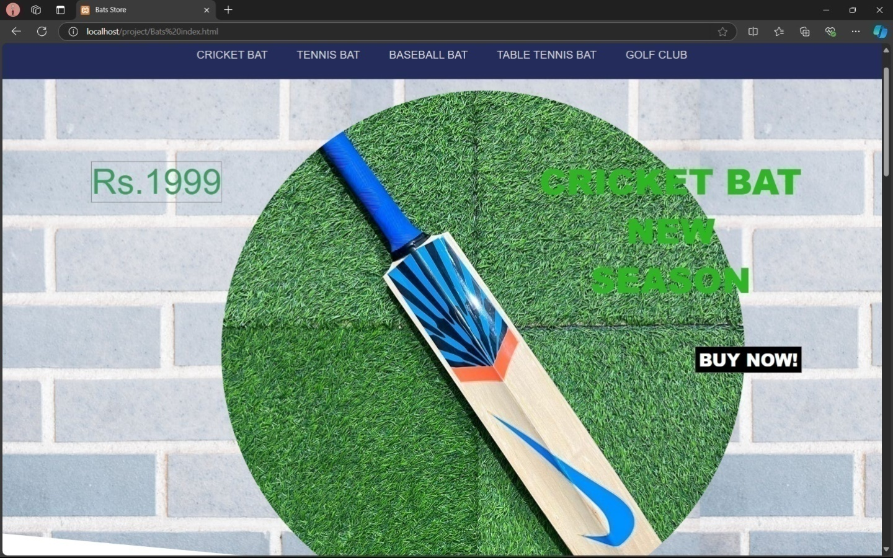

Figure 5: Admin Login

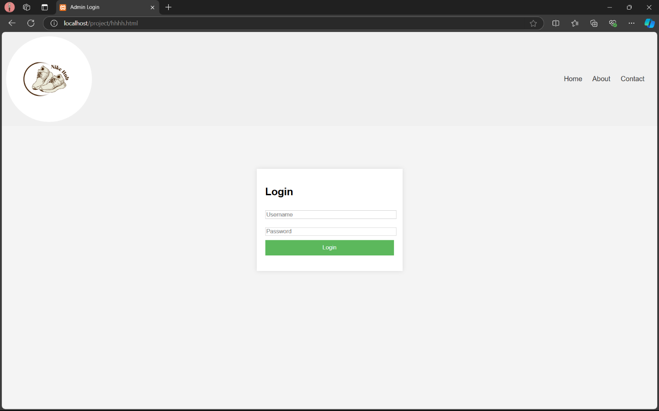

Figure 6: Order Placement

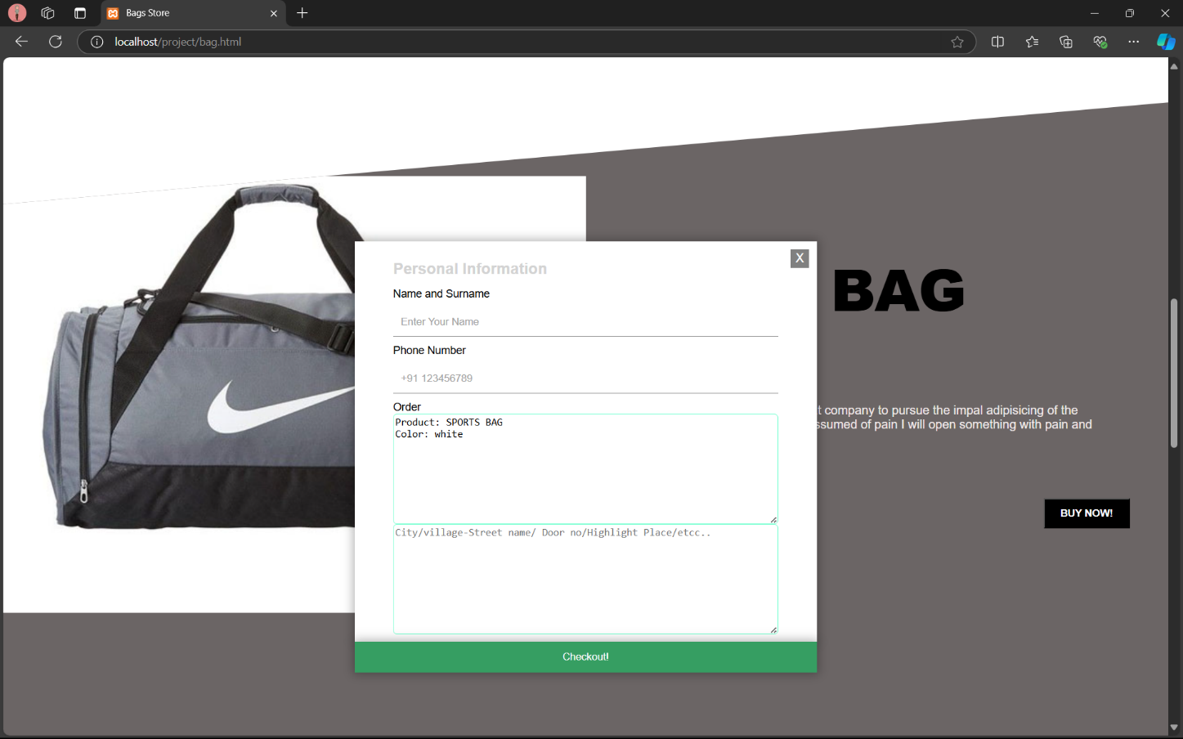

**CHAPTER-9**

**SUMMARY AND CONCLUSION**

### CHAPTER-9

**Summary of Emerging of E-Commerce:** electronic commerce ore-commerce is simply the buying and selling of goods and services using the internet, when shopping online. However , the term is often used to describe all of a seller's efforts ,when selling products directly to consumers.

Conclusion:Research in e-commerce implementation can give a significant result. In order to get an overview of the current research in this area, a system at literature search was undertaken to identify ecommerce implementation articles from four databases. We have found 65 most related articles after inclusion and exclusion criteria process for obtaining the maximum relevance to our study objectives. The articles were published between 2006 and 2015.The results of this review indicate the e-commerce implementation as a whole process is rather inadequately addressed. Although there are extensive studies of factors in e-commerce implementation, we have found the most relevant factors. There are no research efforts, at least in our selected papers, which have actually provided the solution or activities in the e-commerce implementation. Never the less we feel that the results presented in this paper have few imperative implications. This study contributes to the first system at literature review of e-commerce implementation area. Hence the results from this review may assist researchers in the area of ecommerce implementation.